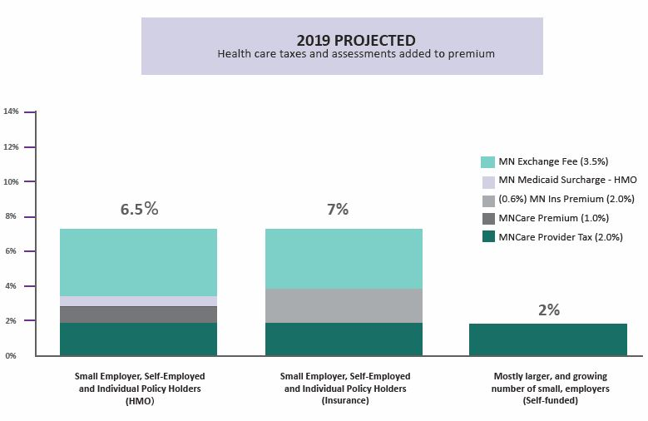
A few more details:
- The ACA Federal Industry Tax of 1.5 to 2.9 percent is not scheduled to be collected in 2019. It is scheduled to return in 2020.
- The 2 percent MinnesotaCare provider tax is assessed on medical bills, not premiums paid. Therefore, the portion of the premium that pays the provider tax is a little less than 2 percent.
- Chart does not include the Minnesota Medicaid surcharge on hospitals (1.56%) or other provider taxes and assessments that may be built into payments to those who provide your care.
- Chart does not include a federal fee on all employer-sponsored insurance that goes toward the Patient-Centered Outcomes Research Trust Fund. That fee is about $2.26 per person.

